Nguyễn Quang Mẫn_1150080065

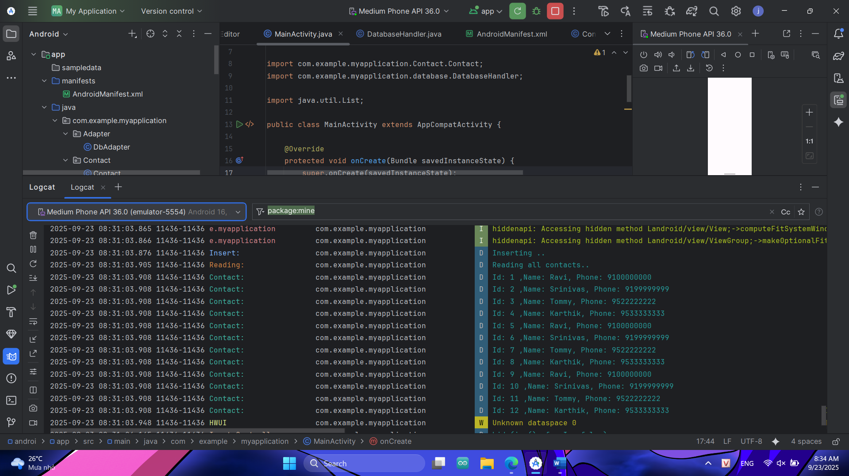

package com.example.myapplication;  
  
import android.os.Bundle;  
import android.util.Log;  
  
import androidx.appcompat.app.AppCompatActivity;  
  
import com.example.myapplication.Contact.Contact;  
import com.example.myapplication.database.DatabaseHandler;  
  
import java.util.List;  
  
public class MainActivity extends AppCompatActivity {  
  
 @Override  
 protected void onCreate(Bundle savedInstanceState) {  
 super.onCreate(savedInstanceState);  
 setContentView(R.layout.*activity_main*);  
  
 DatabaseHandler db = new DatabaseHandler(this);  
  
 // Thêm Contact  
 Log.*d*("Insert: ", "Inserting ..");  
 db.addContact(new Contact("Ravi", "9100000000"));  
 db.addContact(new Contact("Srinivas", "9199999999"));  
 db.addContact(new Contact("Tommy", "9522222222"));  
 db.addContact(new Contact("Karthik", "9533333333"));  
  
 // Đọc tất cả Contact  
 Log.*d*("Reading: ", "Reading all contacts..");  
 List<Contact> contacts = db.getAllContacts();  
  
 for (Contact cn : contacts) {  
 String log = "Id: " + cn.getID() + " ,Name: " + cn.getName() + ", Phone: " + cn.getPhoneNumber();  
 Log.*d*("Contact: ", log);  
 }  
 }  
}

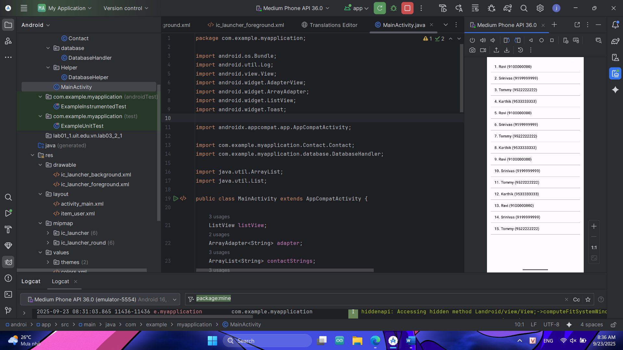

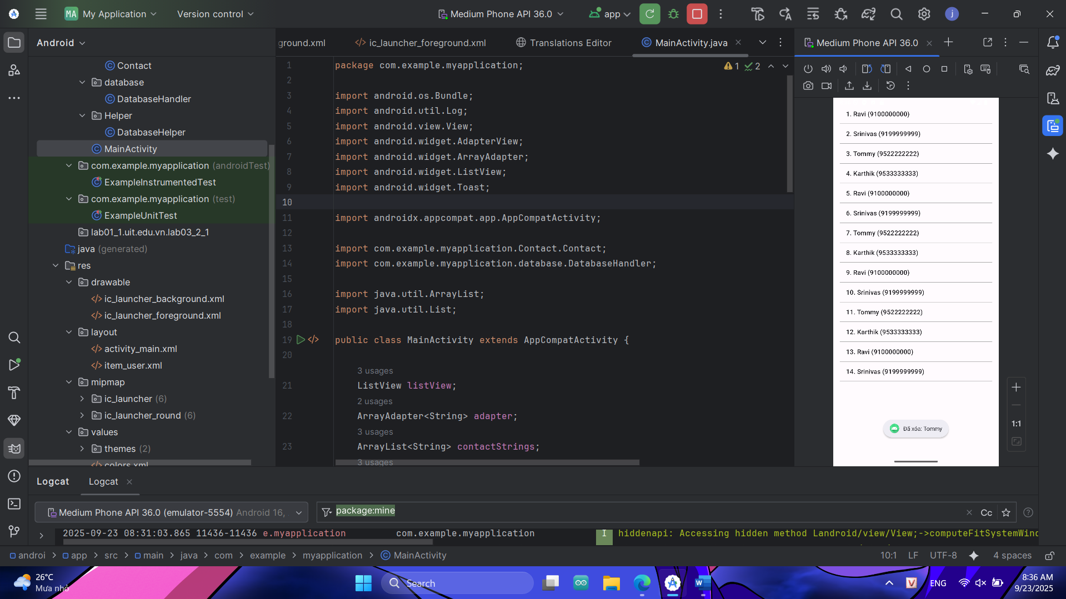

package com.example.myapplication;  
  
import android.os.Bundle;  
import android.util.Log;  
import android.view.View;  
import android.widget.AdapterView;  
import android.widget.ArrayAdapter;  
import android.widget.ListView;  
import android.widget.Toast;  
  
import androidx.appcompat.app.AppCompatActivity;  
  
import com.example.myapplication.Contact.Contact;  
import com.example.myapplication.database.DatabaseHandler;  
  
import java.util.ArrayList;  
import java.util.List;  
  
public class MainActivity extends AppCompatActivity {  
  
 ListView listView;  
 ArrayAdapter<String> adapter;  
 ArrayList<String> contactStrings;  
 List<Contact> contacts;  
 DatabaseHandler db;  
  
 @Override  
 protected void onCreate(Bundle savedInstanceState) {  
 super.onCreate(savedInstanceState);  
 setContentView(R.layout.*activity_main*);  
  
 listView = findViewById(R.id.*listViewContacts*);  
 db = new DatabaseHandler(this);  
  
 // Chèn dữ liệu mẫu  
 db.addContact(new Contact("Ravi", "9100000000"));  
 db.addContact(new Contact("Srinivas", "9199999999"));  
 db.addContact(new Contact("Tommy", "9522222222"));  
 db.addContact(new Contact("Karthik", "9533333333"));  
  
 loadContacts();  
  
 // Xử lý Long Click để xóa Contact  
 listView.setOnItemLongClickListener(new AdapterView.OnItemLongClickListener() {  
 @Override  
 public boolean onItemLongClick(AdapterView<?> parent, View view, int position, long id) {  
 Contact c = contacts.get(position);  
  
 // Xóa khỏi DB  
 db.deleteContact(c.getID());  
  
 // Hiện thông báo  
 Toast.*makeText*(MainActivity.this, "Đã xóa: " + c.getName(), Toast.*LENGTH_SHORT*).show();  
  
 // Tải lại danh sách  
 loadContacts();  
 return true;  
 }  
 });  
 }  
  
 // Hàm load dữ liệu từ DB ra ListView  
 private void loadContacts() {  
 contacts = db.getAllContacts();  
 contactStrings = new ArrayList<>();  
  
 for (Contact cn : contacts) {  
 contactStrings.add(cn.getID() + ". " + cn.getName() + " (" + cn.getPhoneNumber() + ")");  
 Log.*d*("Contact:", cn.getID() + " - " + cn.getName());  
 }  
  
 adapter = new ArrayAdapter<>(this, android.R.layout.*simple_list_item_1*, contactStrings);  
 listView.setAdapter(adapter);  
 }  
}